# Project Report

ON

**“Smart Mirror Using raspberry pi”**

**Submitted for the partial fulfillment of the degree of**

**BACHELOR OF ENGINEERING**

IN

**INFORMATION TECHNOLOGY**

***-: Submitted By: -***

**Mr. Vyankatesh S. Sahu**

**Mr. Madhav P. Ladddha**

**Ms. Jagruti S. Pawar**

**Ms. Anjali S. Bajaj**

**Ms.Pooja P. Wagare**

GUIDED BY

**Prof. A.R.Bhuyar**

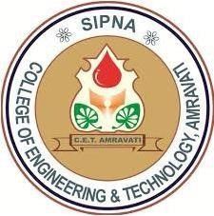

**DEPARTMENT OF INFORMATION TECHNOLOGY**

**(Accredited by NBA)**

**SIPNA COLLEGE OF ENGINEERING & TECHNOLOGY, AMRAVATI**

**ISO 9001: 2015 Certified**

**SANT GADGE BABA AMRAVATI UNIVERSITY, AMRAVATI**

**Year – 2020-2021**

**Project Approval Sheet**

Project Entitled

# “Smart Mirror Using raspberry pi”

-: Submitted By: -

**Mr. Vyankatesh S. Sahu**

**Mr. Madhav P. Ladddha**

**Ms. Jagruti S. Pawar**

**Ms. Anjali S. Bajaj**

**Ms.Pooja P. Wagare**

**Is approved for the degree of**

## Bachelor of Engineering

IN

**INFORMATION TECHNOLOGY**

## Sant Gadge Baba Amravati University, Amravati.

## 2020-20212

|  |  |
| --- | --- |
| **Internal Examiner:** | **External Examiner:** |
| Name: | Name: |
| Date: | Date: |

# *CERTIFICATE*

*This is to certify that the project entitled*

# “Smart Mirror Using raspberry pi”

*Is a Bonafide work and it is submitted to the Sant Gadge Baba University, Amravati.*

## *By*

**Mr. Vyankatesh S. Sahu**

**Mr. Madhav P. Ladddha**

**Ms. Jagruti S. Pawar**

**Ms. Anjali S. Bajaj**

**Ms.Pooja P. Wagare**

In the partial fulfillment of the requirement for the degree of Bachelor of

Engineering (INFORMATION TECHNOLOGY) during academic year 2020- 2021 under my supervision and guidance

|  |  |
| --- | --- |
| Prof. A. R. Bhuyar | Dr. V. S. Gulhane |
| **Guide** | **Head of Department** |

Dr. S. M. Kherde

**Principal**

# Acknowledgement

A moment of pause, to express a deep gratitude to several individuals, without whom this seminar could not have been completed.

We feel immense pleasure to express deep sense of gratitude and indebtedness to our guide **Prof.A.R. Bhuyar** , for constant encouragement and noble guidance.

We express our sincere thanks to **Dr. V.S. Gulhane**, Head, Department of Information Technology and the other staff members of the department for their kind co-operation.

We express our sincere thanks to **Dr. S. M. Kherde**, Principal, Sipna College of Engineering & Technology for his valuable guidance.

We also express my sincere thanks to the library staff members of the college.

Last but not the least we are thankful to our friends and parents whose best wishes are always with us.

**Mr. Vyankatesh S. Sahu**

**Mr. Madhav P. Laddha**

**Ms. Jagruti S. Pawar**

**Ms. Anjali S. Bajaj**

**Ms. Pooja P. Wagare**

INDEX

**Sr. No. Title Page No**

**1** Introduction 9

**1.1** The Problem 9

**1.2** Other Solution 9

**1.3** Our Solution 10

**2** Literature Survey 13

**3** Problem Analysis16

**4** System Analysis 19

## 5. Proposed work 23

## 5.1 How Do Smart Mirror Work 23

**5.1.1.** Smart Mirror As A Mirror 24

**5.1.2.** Smart Mirror As A Information System 24

**5.1.**3. Smart Mirror As A Security System 24

**6**. System requirement 29

**6.1** Hardware Component Overview 29

**6.2** Software Component Overview 31

**7** Result 33

**8**  Conclusion 36

**9** Future scope 38

**10** Applications 40

**11** References 43

**List of Figure**

**Fig. No Title Page No**

1 Flowchart of Smart Mirror 24

**2.** Block Diagram for Smart Mirror 25

**3.** Block Diagram for working of Smart mirror using server 26

**4.** Raspberry pi 29

**5.** Outer structure of Smart mirror HARDWARE DESIGN 30

**6.** Inner structure31

**7**. Smart Mirror Display 33

**8.** Output of open YouTube Command 34

**List of tables**

**Table. No Title Page No**

**1.** Raspberry pi 3 specification 19

## ABSTRACT

This project depicts the design and development of smart mirror that represents an elegant interface for glancing information and also used for various day to day updates. A smart mirror is a system that functions as mirror with additional capability of displaying date, time, current temperature, weather details. To design a smart mirror that receives online news and display it using Internet of things (IoT) circuitry and to provide user a best mirroring experience

Internet of Things (IoT) is a concept where an object having the ability to transfer data over a network without the need for human interaction to human or human to computer. IoT is known for its advantage that can help simplify people's everyday routine. Hence, the researcher comes with a proposed system called Smart Mirror. It is a concept of smart home-based Internet of Things (IoT). This system allows users to access information and also control the lights in the house. Relevant information can be traced such as time and date, weather, warning, traffic, and location map.

In today’s society, information is available to us at a glance through our phones, our laptops, our desktops, and more. But an extra level of interaction is required in order to access the information. As technology grows, technology should grow further and further away from the traditional style of interaction with devices. In the past, information was relayed through paper, then through computers, and in today’s day and age, through our phones and multiple other mediums. Technology should become more integrated into our lives - more seamless and more invisible. We hope to push the envelope further, into the future. We propose a new simple way of connecting with your morning newspaper. We present our idea, the Smart Mirror, information at a glance. Our system aims to deliver your information quickly and comfortably, with a new modern aesthetic. While modern appliances require input through modules such as keyboards or touch screen, we hope to follow a model that can function purely on voice and gesture. We seek to deliver your information during your morning routine and throughout the day, when taking out your phone is not always possible. This will cater to a larger audience base, as the average consumer nowadays hopes to accomplish tasks with minimal active interaction with their adopted technology. This idea has many future applications, such as integration with new virtual or augmented reality devices, or simplifying consumer personal media sources.

**INTRODUCTION**

**Chapter 1**

## 1. INTRODUCTION

In this world everyone needs a comfort life. Modern man has invented different technology for his purpose. In today’s world, people need to be connected and they are willing to access the information easily. Whether it is through the television or internet, people need to be informed and in touch with the current affairs happening around the world. The Internet of Things means interconnection via the internet of computing devices embedded in everyday objects, enabling them to send and receive data. The Internet of Things with its enormous growth widens its applications to the living environment of the people by changing a home to smart home. Smart home is a connected home that connects all type of digital devices to communicate each other through the internet.

### 1.1 THE PROBLEM

In our rapidly developing world, information is always right at your fingertips - on your phone, on your computer, maybe even on your watch. Staying connected with new information is both important for entertainment and daily life. With such a variety of options, there is difficulty in following all of your data streams. Often, during your day, you may end up in a position where it is inconvenient, or even impossible, to take out your phone or computer and check the newest update. You cannot commit to a slower interaction. You need a display to glance at, with the information you need ready to go. However, aesthetics are just as important as displaying information. Keeping an extra computer in your bathroom or hall would be inconvenient, and would not fit well with the look of a modern room. A sleek, simple display, easy for an average consumer, is a necessity in today’s world.

### 1.2 OTHER SOLUTION

There are several products in the market that attempt to be your attractive hub of daily information. The Amazon Echo and the upcoming Google Home present themselves as a small speaker that can relay information through sound. You can request news or music, fulfilling your need to obtain media content in a hands-free manner. However, not all data is suitable for conveyance by voice. Both designs lack the key ability to convey information visually. Asking for the morning traffic can give you a time estimate, but it barely comes close to a detailed map with your route information. Having the news read to you is convenient, but many prefer reading the news at their own pace. A smart display would be a product that would be able to answer all of these concerns, while staying smoothly modern. The Nest thermostat has a small display for information. However, it is not intended for interaction. The interface can be clunky, and not something an average consumer would interact with on a day-to-day basis. The recently Kick- started Perseus hides a screen and computer behind a two-way mirror. This allows users to interact with the mirrors applications via touch 1 screen, voice, and camera controls. Perseus, however, is a finished product, and does not allow user hardware customization. It claims to have an available API and third party applications, but currently, there is little to no information or documentation on this matter. With months to go before its delivery, the success of this product remains uncertain. A few Do-It-Yourself (DIY) alternatives are also currently available. Both the Mirror-Mirror and Smart-Mirror projects provide an application to display information on a monitor behind a mirror. However, these require legwork on the user end, as not all users are willing to manually construct the project from scratch. Manual configuration and tinkering with modules can be a tedious and difficult process.

### 1.3 OUR SOLUTION

Our solution is an open platform for discrete display development. We offer an aesthetically pleasing mirror, with a hidden smart display underneath. With a generic display, the mirror can be built to any size so the information can be both in your face while showing you your face. Our product differs from the competition with an easy-to-use interface that is both simple for the average user and open for the advanced developer. A sleek display gives all levels of users a modern hub of technology for their personal daily interaction, one which both displays visually all the information you could need or want, and operates with a simple interaction that you could fit into your daily routine. By creating a platform open to modification, developers will also be add new functionality at their own pace. This will allow our display to be a tailorable and adaptable platform. A web application provides the interface that the user sees and interacts with.

An online configurator will relieve the frustration and difficulty of personalizing your information, as well as allow streamlined development of new modules. Powered by a small computer, the smart mirror will have great potential for expansion by developers. As an open platform, consumers and developers will be able to easily build, adapt, and hack their smart mirror to fit their own needs. Our product will be a step in the future of IoT, connecting your daily mirror to your tech-savvy world.

**LITERATURE**

**SURVEY**

**Chapter**

**2**

## 2. LITERATURE SURVEY

In 2003 Phillips unveiled their Mirror TV that was built using the same principles that of smart mirrors. Their product was a normal TV that was put behind a two way mirror so that the TV would appear as a mirror when turned on and as TV when turned on. They also had an option to have the mirror be larger than the TV. A usage example presented by Phillips was to have the children watch cartoons while brushing their teeth at the same time. Later in 2005 Phillips announced their research project MyHeart that built upon the idea of an informative mirror. While their original Mirror TV was simply a TV that also functioned as a mirror, the project would integrate a display to showcase various medical statistics. However this project required on-body electronics to collect and analyze the data. The mirror itself simply served as an informative display.[1]

James Law Cyber tecture developed a commercially sold smart mirror in 2011. This mirror is more in line with the smart mirror we’ve come to know today. The product consists of 32"LCDdisplay covered by a 37" two way mirror.[2] The display can show weather forecasts, stream internet, TV, the current time and various widgets. The smart mirror has numerous input methods such as remote controller, smartphone app and onscreen virtual keyboard.[3]

Paper by Franco Chiarugietal (2013) discusses the motivation and rationale behind the project. Their idea was to extract quantitative features official expressions related to stress, anxiety and fatigue and use those features to quantify an individual’s well-being. The features would be extracted from data collected from multisensory devices.[4] The data would be collected in the form of videos, images, 3D face scans and breath samples. The project is first and foremost a research project to digitalize semeiotics - the physical signs produced by diseases - from facial images. At the 2014 International Consumer Electronics Show (CES) Toshiba showcased their smart mirror concept. It utilized gesture control as an input method. Toshiba showcased their smart mirror in different home environments. Their idea was that the smart mirror would be customized for purpose it would serve in each room. The bathroom smart mirror would show information such as weather forecast and a personal fitness monitor.[5]

In 2016 Microsoft released detail on the smart mirror they have been working on. Their intention does not seem to be to create a commercial smart mirror to sell to consumers, but rather they unveiled all the details on how to build one and made all the code publicly available at a git hub repository[6].

Rather than selling a finished product consumers have the option to assemble their own mirror as a do-it-yourself project.

Daniel Bessereretal (2016) created a smart mirror for adding interactive fitness exercises to a person’s morning routine. Their project utilizes the Microsoft Kinectv2 for tracking gestures and a Wii Balance Board for presence detection.[7]

Chidambaram Sethukkara et al. (2016) created an intelligent mirror that identifies users based on facial recognition, recognizes emotions, record health parameters.[8]

and gives clothing advise. Their paper does not go in-depth on any of its subjects, but rather try to unite the ideas under the concept of an intelligent mirror.[9]

In 2017 a company called New Kinpo Group launched their take on the smart mirror called HiMirror. This smart mirror has a camera to specifically monitor your skin health. The mirror will scan your skin and give you metric to tell you what to improve.[10] The mirror uses facial recognition to log a user’s skin firmness, texture, clarity, brightness and health on day to day basis.

**PROBLEM**

**ANALYSIS**

**Chapter**

**3**

### 3. PROBLEM ANALYSIS

The world we live in today has become a place of the fiercest competition, whether it is in sports, entertainment, or the job market. In order to be the best, one needs to allocate an extraordinary amount of time to their goals with little distraction. However, the advent of information technology tends to act like a dual-edged sword when it comes to work productivity; sometimes one can use the ease of information to help them complete a task, but it can also provide significant distraction. Ultimately one strives to be their best, but the interruption of keeping up with the daily news, or preparing for incoming weather can hinder one’s progress. Taking time throughout the day for these various activities can be extremely distracting and greatly cut into performance.

Along with information, people greatly value their appearance, spending approximately an hour a day in front of the mirror during their morning and night routines. This is a significant amount of time where important things are taking place, but the mind is not working. It would be extremely useful to spend that time on the phone or computer completing any of the tasks mentioned above, but unfortunately it is difficult to do so while preparing for the day. A product is needed that can allow a person to efficiently complete everything they need to do to prepare for the day, all in one place and at the same time.

The goal of the Smart Mirror is to provide a single easy to access location for a person to receive all the information that could affect how they prepare for the day. Through the use of LCD displays and a one-way mirror, weather, time and date, and news are available at a glance. Additionally, a user-friendly interface, accessible from any WIFI enabled device, allows the user to easily setup the connection to their home WIFI, change the location from which they receive the weather, and select a source from which to receive the day’s headlines. By building these features into a mirror, which most people will already be using in their morning routine, it is possible to present this information in such a way that it will seamlessly blend together with the task of morning grooming.

Another major problem is, placing the mirror in bathroom for various purposes like getting ready, checking weather, etc. as every electronic device has the fear of being hacked, placing it in bathroom would be a great risk if the device is hacked and would affect the user’s privacy.

**SYSTEM**

**ANALYSIS**

**Chapter**

**4**

**4.SYSTEM ANALYSIS**

**PC Specifications:**

For the smart mirror, a computer will be required to process and display all information to the user. The software for the mirror will be implemented via Universal Windows Platform programs which means they will function on any computer running

Windows 10 or Windows 10 IoT. However, during development, the mirror will utilize a Raspberry Pi 3 Model B as the primary computer. All sensor components will be run through an MCU and fed into the Raspberry Pi. The hardware specifications of the

Raspberry Pi 3 Model B are shown in Table

|  |  |
| --- | --- |
| **Raspberry Pi 3 Model B** |  |
| CPU | Broadcom Quad-Core ARM7 900MHz |
| Memory | 1GB SDRAM |
| Power Supply | 5V micro-USB |
| Wi-Fi Module | 802.11b/g/n |
| Video | HDMI 1.4 |
| Audio | 3.5mm Audio Port |
| USB | 4x USB 2.0 |
| GPIO | 40 pins extended GPIO |

Table 1. Raspberry pi 3 specifications

**Video and Audio Specification:**

For display purposes, a thirty-two-inch television will be utilized. The constraints on the television are flexible, requiring simply a single HDMI input to display the information presented by the Raspberry Pi. For audio implementation, there will be three primary options: the first will be speakers via the television, the second would be internal speakers, while the third would be external speakers.

The first two options would be housed within the mirror itself. Speakers in the television would receive their signal from the HDMI which provides video. Internal speakers not connected directly to the television can receive audio via the 3.5mm audio jack on the Raspberry Pi. Finally, external speakers may be utilized but would require a third-party Bluetooth dongle connected to on the Raspberry Pi’s USB slots.

For the hardware architecture, a computer monitor, a one-way mirror, a Raspberry Pi model 3B, USB microphones, jack speaker are used. Everything was put together in a wooden frame. The entire structure is divided into two wooden parts constructed as a box type structure. The behind part holds the display screen and the Raspberry Pi and is used to support the device so that it can be hung on a wall. The forward portion of the box type structure is made using the glass which is made to fit entirely in front the screen. The major components that are used (the one-way mirror glass, display, Raspberry Pi, microphones and frame).

**1.One-way mirror:**

The glass used at the front end of the box is probably the most important part of the device or hardware as it is this that is responsible for creating the futuristic and artistic effect and is the biggest part of the smart mirror. Here for it to attain the qualities of reflection and refraction, a dark background surface is needed in which light parts or portions will be visible normally.

**2.Display:**

For the display a monitor is used, comes with a remote control which is useful to easily turn off the device’s screen. The monitor is much smaller than the mirror so a black sticker is used to cover the parts of the glass which are not covered by the display. An HDMI to VGA cable was used to connect the display to the Raspberry Pi for video and audio.

**3.Microphones and Speakers:**

One mode of interaction with the smart mirror is through microphones. USB

microphones is used because the Raspberry Pi does not have a regular microphone input.

**4. Raspberry Pi:**

The Raspberry Pi is a single board computer developed by the Raspberry Pi foundation in the UK. The Pi does not work out of the box. It lacks a hard drive and it does not come with a preinstalled operating system. To install an OS microSD card prepared with an OS image is needed. And because the software that runs on the mirror is coded on the same device at least a screen, a keyboard and a mouse are required.

**PROPOSED**

**WORK**

**Chapter**

**5**

## 5. PROPOSED WORK

**5.1 How Do Smart Mirrors Work?**

There are three components of a smart mirror: a two-way mirror, a display, and a computer device. Let’s look at each part and how they run the smart mirror.

Two-Way Mirror: A normal mirror has a film behind the glass that reflects 100% of incoming light. This means when you look at a mirror, you see your reflection. A two-way mirror reflects light from one direction, but allows light to pass through from the other direction.

You’ve probably seen two-way mirrors in the movies in police interrogation rooms. Smart mirrors use two-way mirrors to allow the light from the display to pass through the mirror.

Display: behind the two-way mirror sits a monitor screen/TV/tablet. This is used to display any information or modules for your smart mirror. The display can be the same size as the mirror, or it can be smaller than the mirror.

Throughout this site you’ll see different sized displays used in smart mirrors.

Computer: something has to run the content you see on your smart mirror. A small computer device such as a Raspberry Pi is more than enough to power a smart mirror.

The type of computer device you need depends on what you want your smart mirror to do.

### 5.1.1. Smart Mirror As A Mirror

We can see our view as we can see it in a natural mirror while looking and grooming with the help of one way mirror with high concentration of aluminum content.

### 5.1.2. Smart Mirror as a Information System

Time, Date, weather details and news are fetched from online using predefined URL. News is fetched from websites

Like CCN, BBC etc. DHT22 –digital sensor is used to get the humidity and temperature details.DHT22 is connected to GPIO pins of Raspberry Pi board using jumpers.

#### 5.1.3. Smart Mirror As Security System

When there is nobody in home it can be switched into security system by using VNC viewer to detect human presence. When someone enters into room ,PIR sensor will detect the movement of the person when he passes by the mirror and capture the image and stores it in the drop box .Also informs the owner by updating captured image in the drop-box ,by this way smart mirror system can also be used as a security system.

CAMERA

RASPBERRY PI

DHT22

SENSOR

DROP

BOX

R

230

V POWER SUPPLY

MONITOR

TWO WAY MIRROR

5

V POWER

Fig. Flow Chart of Smart Mirror

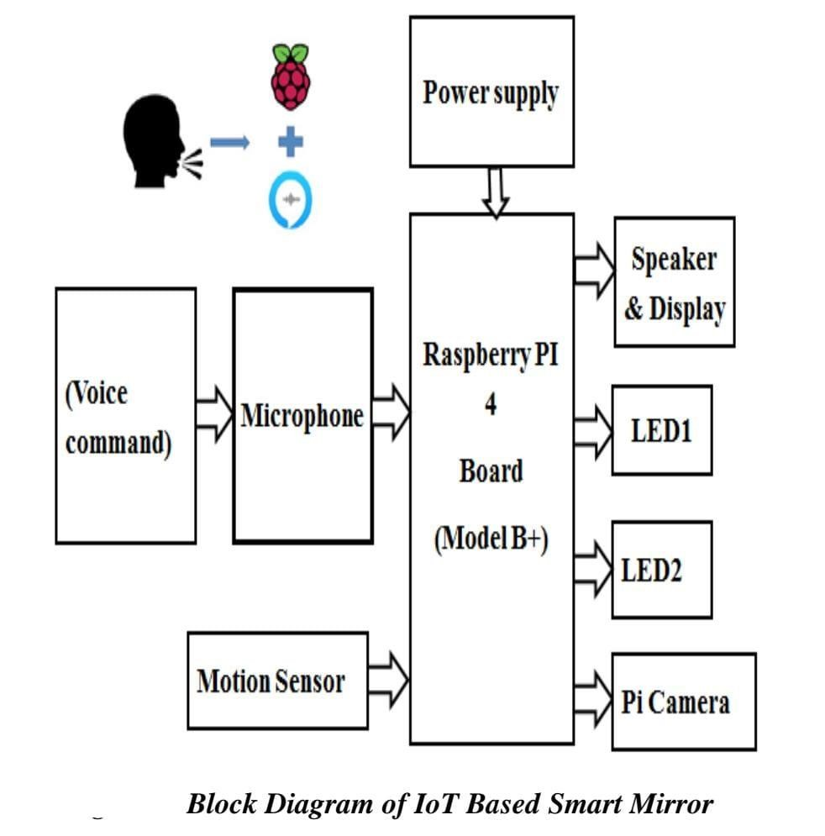

Fig. Block Diagram for Smart Mirror

### ALGORITHMS:-

### Algorithm for Information System

Step 1: Switch on the power supply.

Step 2: Get the date, time, and weather details from predefined from URL.

Step3: Get the news from www.zeenews.com

Step 4: In code section write down all the compliments to be displayed on mirror.

Step 5: Display it on mirror via LCD monitor

Step6: Switch to thief detection mode using VNC viewer.

Step7: Switch off the power supply when it is of no use.

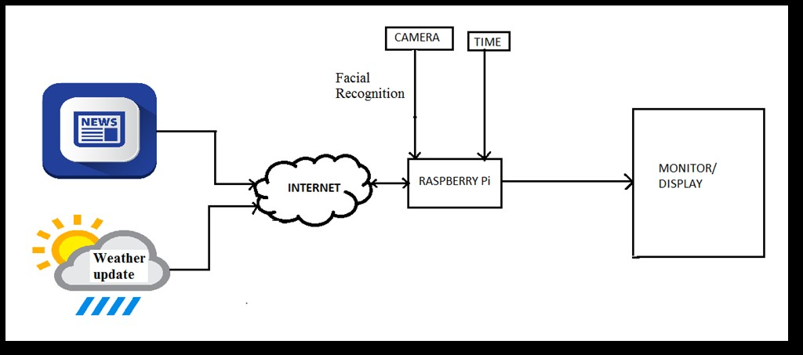

**Fig. Block Diagram for working of Smart mirror using server**

### Algorithm for Thief Detection

Step 1: Start

Step 2: Setup the Camera

Step 3: Check whether PIR sensor output is high or low

Step 4: If it is low, go to step 3.

Step 5: If it is high, camera is turned ON.

Step 6: Image is captured and stored on raspberry pi.

Step 7: Check for Wi-Fi connection.

Step 8: If it is connected image is uploaded to drop-box.

Step 9: Notification is updated in drop-box.

**SYSTEM**

**REQUIREMENT**

**Chapter**

**6**

**6.SYSTEM REQUIREMENT**

### 6.1 HARDWARE COMPONENT OVERVIEW

1. Raspberry Pi:

An SD card inserted into the slot on the board acts as the hard drive for the **Raspberry Pi**. It is a capable little device that enables people of all ages to explore computing.

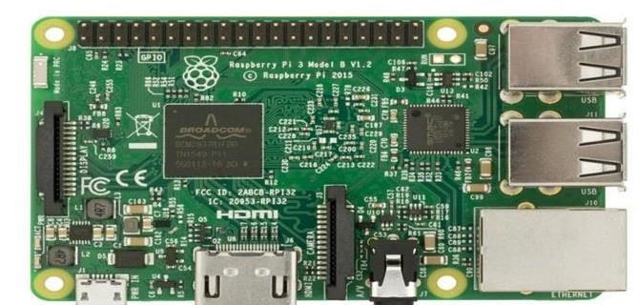

### Raspberry pi

1. Two-way mirror:

Also known as **two**-**way** glass, a **two**-**way mirror** is glass that is reflective on one side and clear on the other, giving the appearance of a **mirror** to those who see the reflection but allowing people on the clear side to see through, as if at a window.

1. LCD panel:

A **liquid-crystal display** (LCD) is a flat-panel display or other electronically modulated optical device.

1. Microphone:

**Smart Mirror** can be easily built by using one way mirror, concealed LED screen and **microphone** to make it interactive.

1. Speaker:

Speaker can be attached to raspberry pi or alexa so that we can interact with Smart mirror or listen to music or audio through our Smart mirror.

1. Wooden Frame:

To frame the two way mirror and assemble the raspberry pi and other hardware components.

1. Camera: capable of monitoring human **within** a coverage range of **camera**.

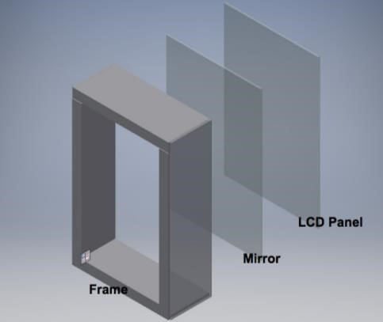

### . Fig.Outer structure of Smart mirror HARDWARE DESIGN

Hardware Design On the outside, the hardware is encapsulated within a wooden frame. On the front, a two-way mirror is placed in front of a LCD monitor. This way, the system can act as a mirror when not currently in use, while the LCD projects through the mirror when in use.

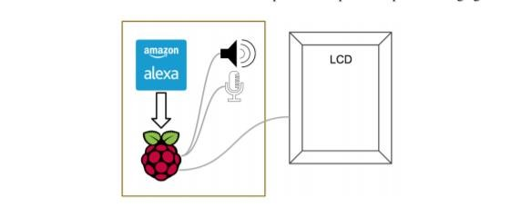

**Inner structure**

The wooden frame has a bezel on the front which the mirror and LCD panel are pressed against. Cutouts for dowels are added in line with the back of the LCD panel to keep the components snug against the bezel.Inside Behind the LCD panel is the heart of the product, the Raspberry Pi, which is connected to the LCD for visual display. We also have a microphone and speaker attached for audio input and output. The Raspberry Pi runs our software and also allows us to connect to the Internet for web services, such as Amazon’s Alexa Voice Service.

### 6.2 SOFTWARE COMPONENT OVERVIEW

1. Raspbian OS
2. Alexa voice service
3. Magic mirror interface

**RESULT**

**Chapter**

**7**

**7.Result**

### 

Fig. Smart Mirror Display

When we switch on the smart mirror , it Displays time, weather , etc. as shown in above image.

### 

### Fig. Output of open YouTube Command

### When user gives command “Open YouTube” Then Smart mirror will Ask for the topic to be searched on YouTube and then Opens YouTube as shown in above image

### 

**CONCLUSION**

**Chapter**

**8**

## 8. CONCLUSION

Smart mirrors have great potential to enhance user experience of accessing and interacting with information. Not only do they allow users to see relevant information effortlessly, they can also be integrated as a thief detection system. Our smart mirror saves time and makes it easier to access information. In today’s society security is of crucial importance. By keeping this in mind we have integrated a thief detection system into our smart mirror .In future this project can be improved by adding interactive touch screen ,geo-location, Alexa and some more features.

**FUTURE**

**SCOPE**

**Chapter**

**9**

#### 9.FUTURE SCOPE

Nothing is perfect and complete and there is always a scope of improvement in each and every product. Everything needs to be updated or upgraded on a timely basis to cope up with the current technology. Apart from up gradation there can be many other features as well which could add up to the proficiency and ability of our smart mirror. There are many future scopes for this paper and hopefully it will emerge into biggest benefit in the field of artificial intelligence. The most basic feature can be smart mirror-based home automation which will provide a natural means of interaction by which we can control the household appliances like switch on/off light and fans through basic voice commands. Majorly, since we are using this mirror in college environment, basic functionalities like barcode scanner or finger print sensor can be integrated to fulfill basic tasks such as college attendance or program registrations etc. This could include registering in programs by scanning of ID cards.

**APPLICATIONS**

**Chapter 10**

## 10. APPLICATIONS

A smart mirror is a device that functions as a mirror with additional capability of displaying multimedia data, such as text, images, and videos. This device allows users to access and interact with contextual information, such as weather data, seamlessly as part of their daily routine.

Among the application segment, the hospitality and retail smart mirror segment is expected to grow at the highest CAGR during the forecast period. Smart mirrors are often used in the retail sector wherein retailers try to catch the interest of potential clients and encourage them for frequent or regular visits.

It can use in at Office for information purpose. At home & vehicles as informative gadget.

### Home Decor

It can be used in our Drawing room, bed room, bath rooms, or any other place which can enhance the look of your house, and attract people towards it.

### Smart-Home

As we are providing inbuilt thief detection system with this smart mirror, it will be easy for you to look out to your home. Which will make your home smart.

### Security

Smart mirror is a system that not only works as a normal mirror but also provides Security against intrusion inside the home.

### As assistant

While you go through your morning routine you can look at your mirror and see a traffic report, weather forecast for the day, and your day’s schedule And many more...

**Advantages**:

1. The big advantage of a smart mirror is the ability to display useful information like weather, time, calender, meetings scheduled on google calender.
2. You simply look at your smart mirror and the information is there. For example, imagine the mirror in your bathroom is a smart mirror.
3. Smart Mirrors are interactive devices that helps you check updates easily with voice control.
4. You can do things at the same time in the morning like brushing your teeth while catching up on the meeting updates , weather or traffic.
5. you can watch shows while preparing going to work.

**REFERENCES**

**Chapter 11**

## 11. REFRENCES

1. B. Cvetkoska, N. Marina, D. C. Bogatinoska and Z. Mitreski, "Smart mirror E-health assistant — Posture analyze algorithm proposed model for upright posture," IEEE EUROCON 2017 -17th International Conference on Smart Technologies, Ohrid, 2017, pp. 507-512
2. M. M. Yusri et al., "Smart mirror for smart life," 2017 6th ICT International Student Project Conference (ICT-ISPC), Skudai, 2017, pp. 1-5.
3. D. Gold, D. Sollinger and Indratmo, "Smart_Reflect: A modular smart mirror application platform," 2016 IEEE 7th Annual Information Technology, Electronics and Mobile Communication Conference (IEMCON), Vancouver, BC, 2016, pp. 1-7
4. O. Gomez-Carmona and D. Casado-Mansilla, "SmiWork: An interactive smart mirror platform for workplace health promotion," 2017 2nd International Multidisciplinary Conference on Computer and Energy Science (SpliTech), Split, 2017, pp. 1-6.
5. S. Athira, F. Francis, R. Raphel, N. S. Sachin, S. Porinchu and S. Francis, "Smart mirror: A novel framework for interactive display," 2016 International Conference on Circuit, Power and Computing Technologies (ICCPCT), Nagercoil, 2016, pp. 1-6.
6. M. Rodriguez-Martinez et al., "Smart Mirrors: peer-to-peer Web services for publishing electronic documents," 14th International Workshop Research Issues on Data Engineering: Web Services for eCommerce and e-Government Applications, 2004. Proceedings., 2004, pp. 121128.
7. Yuan-Chih Yu, S. c. D. You and Dwen-Ren Tsai, "Magic mirror table with social-emotion awareness for the smart home," 2012 IEEE International Conference on Consumer Electronics (ICCE), Las Vegas, NV, 2012, pp. 185-186.
8. Sun Yong.Geng Liqing*,Dan Ke,”Design of Smart Mirror Based On Raspberry-

Pi”,International Conference on Intelligent Trasnsportation ,Big Data &Smart City,2018.

1. R.Akshaya,N.NiroshimaRaj.S.Gowri,”Smart Mirror-Digital Magazine for University implemented Using Raspberry Pi”,International Conference on Emerging Trends and Innovation in Engineering and Technological Research,2018.
2. Ayushman Johri,Raghav Narain Wahi,Sana Jafri,Dr.Dhiraj Pandey,”Smart Mirror: A time saving and Affordable Assistant”,International Conference on Computing Communication and Automation,2018.
3. Kun Jin,Xibo Deng,Zhi Huang,Shaochang Chen,” Design Design of Smart Mirror based on Raspberry Pi”,Advanced Information Manangement, Communicates ,Electronic and Automation Control Conference,2018.